ONE 2 TEN

Multi Support Marketing Strategy
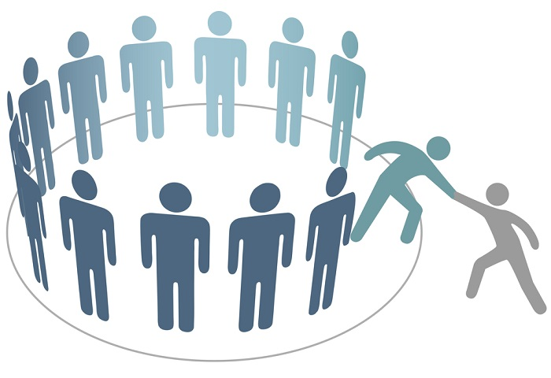
Digital Platforms for Multi Support Marketing

Effective website and APP

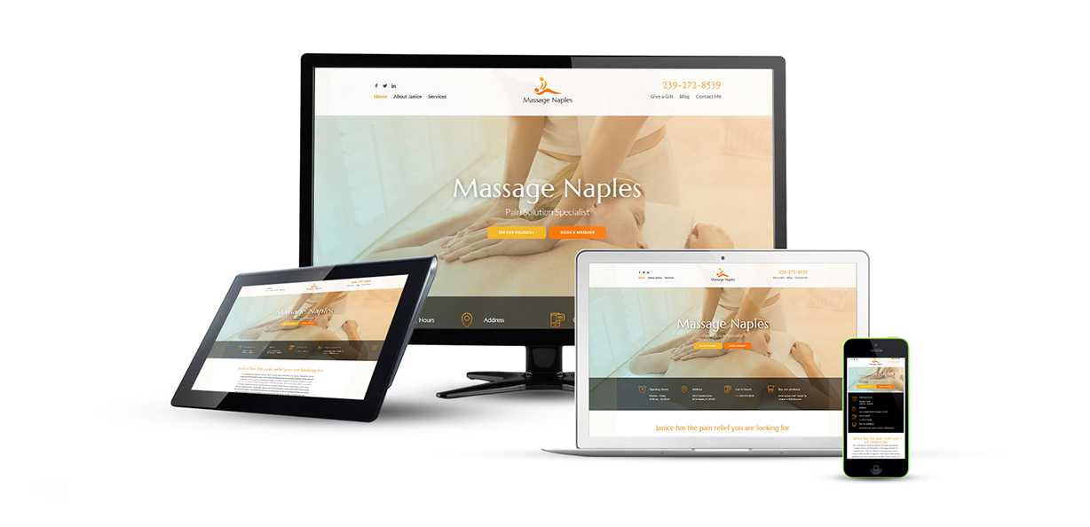
Understand, Contact via Phone, email, WhatsApp etc.
Personal Data form
PayOuts
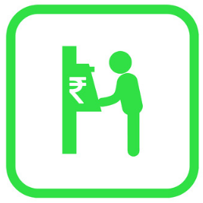
Ontime Payouts
with right payments

Budgeting

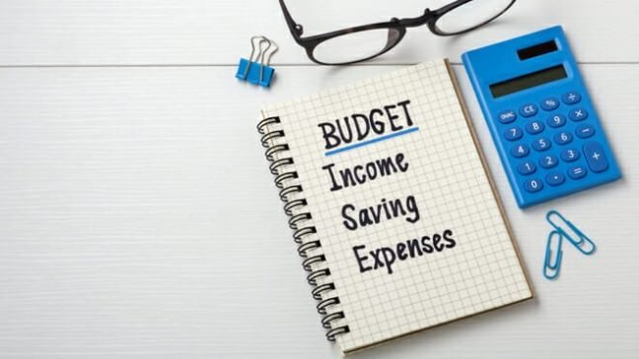
Setting-Up weekly and monthly budget Plan to grow

Effective Plan
Plan to earn and support each member to grow and support next member to grow

Secure
Secure Long time
Part time business

Google - MyBusiness


Free listing in MyBusiness

Membership Program:
The very first step of digital marketing for our business is very effective programme. Our membership programme starts with a registration of one person by purchasing a product for a nominal amount and he will get enrolled as a member (without a product this business is not legal). Once person will become a member, his next step is to inspire and motivate others to become a member, and that way the registered member will keep on getting his fixed payment share as per programme for his part time efforts for motivating, inspiring and getting 10 persons register and become the members with the company.

Membership Income:
As soon as a member registers himself with the company he will get his ID generated, and he will have to pay Rs. 3000/- for the registration. Automated website will create a wallet credited with 3000 points to purchase a product listed on our website, this product will be delivered to his registered address. In the next step he will have to put a little effort to inspire others to get join with our company and become a member and for every member he inspire to join, he will get a 1000 points credited to his wallet(each point is equal to Rs. 1/-), this he will have to do for 10 members. For getting 10 members joined with the company he will have 10000 points credited to his wallet and he will get an option activated for payment to the bank, and we will make a payment of his income (after TDS) direct to his account.
The member will have an option to restart and we will get a new ID generated for him by automatically transferring 3000 points for new ID and this time repeating member will have to make inspire only 9 members to get 10000 points credit to his wallet. The 10th member will automatically will come from the support room available for repeating members.

Effective Website:
Our website will have following 4 main modules.

- A general website with a home page, about us, company history and testimonials, contact us, and a login page for members

- After a member login he will have access to his profile, his down-line members profile (restricted), his wallet points, selection of products, purchased products, sweep own down-line member to other member. Etc.

- An admin login module for administration for managing all the members activities, all different types of reports, all the members up-line and down-line reports, wallet and points reports, products control, payments receipts, profiles of members, OTP, WhatsApp information.

- Mobile APP for Android and IOS, same as members login page.

GUI: Our website should be fast opening, simple, good looking, immediate information availability, easy readable, easy contact information like chat response, phone response and email response, members login, wallet report, profile report. Further more Online Payment Gateway Ready for future.

WhatsApp and SMS:
Creating attractive offers images and promotion for repeating and referring customers. Different types of Discount Coupons for weekdays and weekends and different time zone etc.

FLOW CHART

- Mobile App: Registration
- Backend approval
- Wallet
- Products
- Members transfer
- Calculation

First screen after download and install the app by a member

www.
Home - About us – Future – ReachUs –
Members Area

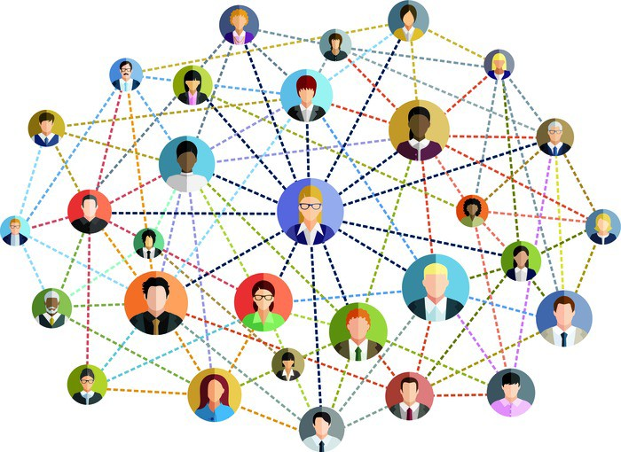

Copy Right (C) DKBK.IN all rights reserved – Designed by TWSN developed by Dreamsoft
Members Login

www.
VERIFY
Enter Verification code here
REGISTER
Home - About us – Future – ReachUs –
Members Area

When you tap on register you agree terms and conditions of the company as stated in terms and conditions page
9341807007

Please Enter your Mobile Number to register

Copy Right (C) DKBK.IN all rights reserved – Designed by TWSN developed by Dreamsoft
Members Login

AFTER Verification we will generate a permanent ID and that is his/her phone number
Next screen will have him see his ID and the his wallet details and approval information
www.
Home - About us – Future – Reach Us –
Members Area

APPROVAL of your ID 9341807007 is awaited kindly tap on Members Profile and complete your details
THANK YOU
PHOTO
9341807007

Members Profile

Copy Right (C) DKBK.IN all rights reserved – Designed by TWSN developed by Dreamsoft
Members Login

www.
Home - About us – Future – Reach Us –
Members Area

ADD / SAVE

Aadhaar image
BACK
PAN

Aadhaar image
FRONT
DL if you have
Cancelled Cheque or Front page of PASS Book

Please upload images of your documents and rest of the information we will complete for you.
NAME
PHOTO
9341807007

Members Profile

Copy Right (C) DKBK.IN all rights reserved – Designed by TWSN developed by Dreamsoft
Members Login

www.
ID / Name / Photo
ID / Name / Photo
ID / Name / Photo
ID / Name / Photo
ID / Name / Photo
Product Purchased

Wallet Points
Wallet Points
Wallet Points
P-3000
M-5000

MID4
MID3
MID2
Home - About us – Future – Reach Us –
Members Area

ID / Name / Photo
ID / Name / Photo
ID / Name / Photo
ID / Name / Photo
ID / Name / Photo
Click to see full image

Upline
PHOTO

Upline/Name /ID

Downliine Members

MI0001
Mohammed Iqbal
PHOTO
9341807007

SUMMARY

Members Profile

Copy Right (C) DKBK.IN all rights reserved – Designed by TWSN developed by Dreamsoft
Members Login

www.
Home - About us – Future – Reach Us –
Members Area

APPROVAL of your ID 9341807007 is awaited kindly tap on Members Profile and complete your details
THANK YOU
PHOTO
9341807007

Members Profile

Copy Right (C) DKBK.IN all rights reserved – Designed by TWSN developed by Dreamsoft
Members Login

www.
Home - About us – Future – Reach Us –
Members Area

APPROVAL of your ID 9341807007 is awaited kindly tap on Members Profile and complete your details
THANK YOU
PHOTO
9341807007

Members Profile

Copy Right (C) DKBK.IN all rights reserved – Designed by TWSN developed by Dreamsoft
Members Login

www.
Home - About us – Future – ReachUs –
Members Area

Copy Right (C) One2Ten.com all rights reserved -
Members Login
Home page - About US - Future – Reach Us
Multi-Level Marketing is a marketing strategy used mostly by pyramid-structured companies for selling products and services, where workers act as both salespeople and buyers and the revenue of an MLM company is then derived from this non-salaried workforce.

The scheme of earning commission-based remuneration and perks depending upon the performance of the network marketer was seen as a cost-effective method of earning from home and has provided for opportunities under the MLM business in India. This business works on the direct selling model where the buyer directly purchases a product from the company, instead of involving a middleman.

www.
Verification Code:
Home - About us – Future – ReachUs –
Members Area

MEMBERS LOGIN

Please Read Terms and Conditions:

LOGIN
Members accepted terms and conditions
Phone No.
Testimonials:

www.
Home - About us – Future – ReachUs –

Present ID: US2011001

Name: Umar Sharief Phone: 1234567890

Wallet Points: 6000 as on 14/11/2020 (click to get details)

Members List:
No. | Name | ID | Since
1. | Ameen Syed | AS2011001 | 2 months
2 | Shaikh Sameer | SS2011001 | Goal
3 | Wali Rehman | WR2011002 | 6 weeks
4 | Shoieb Aakhtar | SA2011003 | 6 weeks
5 | Sameuell R | SR2011001 | 5 weeks
6 | Shafi Shaikh | SS2011002 | 5 weeks
7
8
9
10

Summary
Down-line Members

Up-line Member

Products Purchased

Sweep-Member

Request Support

Message Box

Pay-Outs

Profile Up-Date

www.
Home - About us – Future – ReachUs –

PHOTO
Name: Umar Sharief Present ID: US2011001

Members List:
No. | Name | ID | Since
1. | Ameen Syed | AS2011001 | 2 months
2 | Shaikh Sameer | SS2011001 | Goal
3 | Wali Rehman | WR2011002 | 6 weeks
4 | Shoieb Aakhtar | SA2011003 | 6 weeks
5 | Sameuell R | SR2011001 | 5 weeks
6 | Shafi Shaikh | SS2011002 | 5 weeks
7
8
9
10
Member: Ameen Syed
ID: AS2011001 (Active) / Down Line : 5 Members
Registered on: 06/09/2020
Mobile No.: 9821232425
Summary
Down-line Members

Up-line Member

Products Purchased

Sweep-Member

Request Support

Message Box

Pay-Outs

Profile Up-Date

www.
Home - About us – Future – ReachUs –

PHOTO
Name: Umar Sharief Present ID: US2011001

UP-Line Members List:
Member: Mohammed Salim
ID: MS20110002 (Active) / Down Line : 7 Members
Registered on: 06/09/2020
Mobile No.: 9821232425

Summary
Down-line Members

Up-line Member

Products Purchased

Sweep-Member

Request Support

Message Box

Pay-Outs

Profile Up-Date

www.
Home - About us – Future – ReachUs –

Product Details / Rate / Photo etc.
Product Details / Rate / Photo etc.
Product Details / Rate / Photo etc.
Product Details / Rate / Photo etc.
Product Details / Rate / Photo etc.
Product Details / Rate / Photo etc.
Product Details / Rate / Photo etc.
Name: Umar Sharief Present ID: US2011001

Last Product Purchased:

Other Products available
Summary
Down-line Members

Up-line Member

Products Purchased

Sweep-Member

Request Support

Message Box

Pay-Outs

Profile Up-Date

www.
Home - About us – Future – ReachUs –

PHOTO
CONFIRM
123456
MS2011002
Name: Umar Sharief Present ID: US2011001
Select a member to sweep to support other member
No. | Name | ID | Since
1. | Ameen Syed | AS2011001 | 2 months
2 | Shaikh Sameer | SS2011001 | Goal
3 | Wali Rehman | WR2011002 | 6 weeks
4 | Shoieb Aakhtar | SA2011003 | 6 weeks
5 | Sameuell R | SR2011001 | 5 weeks
6 | Shafi Shaikh | SS2011002 | 5 weeks
7
8
9
10
Enter ID of the Member
you want to Support to:
Member: Mohammed Salim
ID: MS20110002 (Active) with 9 Members
Enter Verification code to Sweep:
Summary
Down-line Members

Up-line Member

Products Purchased

Sweep-Member

Request Support

Message Box

Pay-Outs

Profile Up-Date

www.
Home - About us – Future – ReachUs –

YES
PHOTO
Name: Umar Sharief Present ID: US2011001
Following member have completed 9 members and requested support:
No. | Name | ID | Since
1. | Ameen Syed | AS2011001 | 2 months
2 | Sameuell R | SR2011001 | 5 weeks
3 | Wali Rehman | WR2011002 | 6 weeks
Member: Wali Rehman
ID: AS2011001 (Active) with 9 Members
Registered on: 06/09/2020
Mobile No.: 9821232425
Do you Want to Support this member:
Summary
Down-line Members

Up-line Member

Products Purchased

Sweep-Member

Request Support

Message Box

Pay-Outs

Profile Up-Date

www.
Home - About us – Future – ReachUs –

Message from Wali Rehmani
Thank you brother you have supported me and I have completed my 10 members, I m going for new ID and I will be in your downline with a new ID. Thanks again
PHOTO
Name: Umar Sharief Present ID: US2011001
Following member have completed 9 members and requested support:
No. | Name | ID | Message Read
1. | Ameen Syed | AS2011001 | Y
2 | Sameuell R | SR2011001 | Y
3 | Wali Rehman | WR2011002 | Read

Summary
Down-line Members

Up-line Member

Products Purchased

Sweep-Member

Request Support

Message Box

Pay-Outs

Profile Up-Date

www.
Home - About us – Future – ReachUs –

RECEIPT
Pay-out of Rs. 10000.00
Less - Tax – GST 1800.00
Less New ID Purchased 3000.00
Total Transferred to your Bank 5200.00
On 01/12/2020 vide transaction No. X1517230011

Name: Umar Sharief Present ID: US2011001
PAY-OUT Details
No. | ID | Created | Members | Support | Pay-Out
1 | US2011001 | 12/09/2020 | 9 | 1 | 5200.00
2 | US2012007 | 01/12/2020 | 0 | 0

Summary
Down-line Members

Up-line Member

Products Purchased

Sweep-Member

Request Support

Message Box

Pay-Outs

Profile Up-Date

www.
PHOTO
LICENCE

Cancelled Cheque image
Aadhar
Home - About us – Future – ReachUs –

PAN
Name: Umar Sharief Present ID: US2011007

Login ID: 9821223344

Phone No.: 9821223344

Password : ________________ (Change PW)

Bank Account Details: (Update)
Account Name:
Account No.:
Bank Name: IFS Code: Branch:

KYC Details: (COMPLETED)
Summary
Down-line Members

Up-line Member

Products Purchased

Sweep-Member

Request Support

Message Box

Pay-Outs

Profile UpDate

www.
Total USERS
Total USERS
Total USERS
REPORTS
Repeated M
9 Members
5 Members
< 5 Members
Payout for NOVEMBER

259456
Total USERS
Total Pay-OUT Rs.

52954600
Total Members

40222
Home - About us – Future – ReachUs – SUPER ADMIN

Active Members

34216
SUMMARY REPORT
Summary

www.
Home - About us – Future – ReachUs –
Members Login

Home page - About US - Future – Reach Us
Multi-Level Marketing is a marketing strategy used mostly by pyramid-structured companies for selling products and services, where workers act as both salespeople and buyers and the revenue of an MLM company is then derived from this non-salaried workforce.

The scheme of earning commission-based remuneration and perks depending upon the performance of the network marketer was seen as a cost-effective method of earning from home and has provided for opportunities under the MLM business in India. This business works on the direct selling model where the buyer directly purchases a product from the company, instead of involving a middleman.

www.
Home - About us – Future – ReachUs –
Members Login

Home page - About US - Future – Reach Us
Multi-Level Marketing is a marketing strategy used mostly by pyramid-structured companies for selling products and services, where workers act as both salespeople and buyers and the revenue of an MLM company is then derived from this non-salaried workforce.

The scheme of earning commission-based remuneration and perks depending upon the performance of the network marketer was seen as a cost-effective method of earning from home and has provided for opportunities under the MLM business in India. This business works on the direct selling model where the buyer directly purchases a product from the company, instead of involving a middleman.

www.
Home - About us – Future – ReachUs –
Members Login

Home page - About US - Future – Reach Us
Multi-Level Marketing is a marketing strategy used mostly by pyramid-structured companies for selling products and services, where workers act as both salespeople and buyers and the revenue of an MLM company is then derived from this non-salaried workforce.

The scheme of earning commission-based remuneration and perks depending upon the performance of the network marketer was seen as a cost-effective method of earning from home and has provided for opportunities under the MLM business in India. This business works on the direct selling model where the buyer directly purchases a product from the company, instead of involving a middleman.

www.
Home - About us – Future – ReachUs –
Members Login

Home page - About US - Future – Reach Us
Multi-Level Marketing is a marketing strategy used mostly by pyramid-structured companies for selling products and services, where workers act as both salespeople and buyers and the revenue of an MLM company is then derived from this non-salaried workforce.

The scheme of earning commission-based remuneration and perks depending upon the performance of the network marketer was seen as a cost-effective method of earning from home and has provided for opportunities under the MLM business in India. This business works on the direct selling model where the buyer directly purchases a product from the company, instead of involving a middleman.

www.
Home - About us – Future – ReachUs –
Members Login

Home page - About US - Future – Reach Us
Multi-Level Marketing is a marketing strategy used mostly by pyramid-structured companies for selling products and services, where workers act as both salespeople and buyers and the revenue of an MLM company is then derived from this non-salaried workforce.

The scheme of earning commission-based remuneration and perks depending upon the performance of the network marketer was seen as a cost-effective method of earning from home and has provided for opportunities under the MLM business in India. This business works on the direct selling model where the buyer directly purchases a product from the company, instead of involving a middleman.

www.
Home - About us – Future – ReachUs –
Members Login

Home page - About US - Future – Reach Us
Multi-Level Marketing is a marketing strategy used mostly by pyramid-structured companies for selling products and services, where workers act as both salespeople and buyers and the revenue of an MLM company is then derived from this non-salaried workforce.

The scheme of earning commission-based remuneration and perks depending upon the performance of the network marketer was seen as a cost-effective method of earning from home and has provided for opportunities under the MLM business in India. This business works on the direct selling model where the buyer directly purchases a product from the company, instead of involving a middleman.

www.
Home - About us – Future – ReachUs –
Members Login

Home page - About US - Future – Reach Us
Multi-Level Marketing is a marketing strategy used mostly by pyramid-structured companies for selling products and services, where workers act as both salespeople and buyers and the revenue of an MLM company is then derived from this non-salaried workforce.

The scheme of earning commission-based remuneration and perks depending upon the performance of the network marketer was seen as a cost-effective method of earning from home and has provided for opportunities under the MLM business in India. This business works on the direct selling model where the buyer directly purchases a product from the company, instead of involving a middleman.

www.
Home - About us – Future – ReachUs –
Members Login

Home page - About US - Future – Reach Us
Multi-Level Marketing is a marketing strategy used mostly by pyramid-structured companies for selling products and services, where workers act as both salespeople and buyers and the revenue of an MLM company is then derived from this non-salaried workforce.

The scheme of earning commission-based remuneration and perks depending upon the performance of the network marketer was seen as a cost-effective method of earning from home and has provided for opportunities under the MLM business in India. This business works on the direct selling model where the buyer directly purchases a product from the company, instead of involving a middleman.

www.
Home - About us – Future – ReachUs –
Members Login

Home page - About US - Future – Reach Us
Multi-Level Marketing is a marketing strategy used mostly by pyramid-structured companies for selling products and services, where workers act as both salespeople and buyers and the revenue of an MLM company is then derived from this non-salaried workforce.

The scheme of earning commission-based remuneration and perks depending upon the performance of the network marketer was seen as a cost-effective method of earning from home and has provided for opportunities under the MLM business in India. This business works on the direct selling model where the buyer directly purchases a product from the company, instead of involving a middleman.

www.
Home - About us – Future – ReachUs –
Members Login

Home page - About US - Future – Reach Us
Multi-Level Marketing is a marketing strategy used mostly by pyramid-structured companies for selling products and services, where workers act as both salespeople and buyers and the revenue of an MLM company is then derived from this non-salaried workforce.

The scheme of earning commission-based remuneration and perks depending upon the performance of the network marketer was seen as a cost-effective method of earning from home and has provided for opportunities under the MLM business in India. This business works on the direct selling model where the buyer directly purchases a product from the company, instead of involving a middleman.

www.
Home - About us – Future – ReachUs –
Members Login

Home page - About US - Future – Reach Us
Multi-Level Marketing is a marketing strategy used mostly by pyramid-structured companies for selling products and services, where workers act as both salespeople and buyers and the revenue of an MLM company is then derived from this non-salaried workforce.

The scheme of earning commission-based remuneration and perks depending upon the performance of the network marketer was seen as a cost-effective method of earning from home and has provided for opportunities under the MLM business in India. This business works on the direct selling model where the buyer directly purchases a product from the company, instead of involving a middleman.

www.
Home - About us – Future – ReachUs –
Members Login

Home page - About US - Future – Reach Us
Multi-Level Marketing is a marketing strategy used mostly by pyramid-structured companies for selling products and services, where workers act as both salespeople and buyers and the revenue of an MLM company is then derived from this non-salaried workforce.

The scheme of earning commission-based remuneration and perks depending upon the performance of the network marketer was seen as a cost-effective method of earning from home and has provided for opportunities under the MLM business in India. This business works on the direct selling model where the buyer directly purchases a product from the company, instead of involving a middleman.

www.
Home - About us – Future – ReachUs –
Members Login

Home page - About US - Future – Reach Us
Multi-Level Marketing is a marketing strategy used mostly by pyramid-structured companies for selling products and services, where workers act as both salespeople and buyers and the revenue of an MLM company is then derived from this non-salaried workforce.

The scheme of earning commission-based remuneration and perks depending upon the performance of the network marketer was seen as a cost-effective method of earning from home and has provided for opportunities under the MLM business in India. This business works on the direct selling model where the buyer directly purchases a product from the company, instead of involving a middleman.

www.
Home - About us – Future – ReachUs –
Members Login

Home page - About US - Future – Reach Us
Multi-Level Marketing is a marketing strategy used mostly by pyramid-structured companies for selling products and services, where workers act as both salespeople and buyers and the revenue of an MLM company is then derived from this non-salaried workforce.

The scheme of earning commission-based remuneration and perks depending upon the performance of the network marketer was seen as a cost-effective method of earning from home and has provided for opportunities under the MLM business in India. This business works on the direct selling model where the buyer directly purchases a product from the company, instead of involving a middleman.

www.
Home - About us – Future – ReachUs –
Members Login

Home page - About US - Future – Reach Us
Multi-Level Marketing is a marketing strategy used mostly by pyramid-structured companies for selling products and services, where workers act as both salespeople and buyers and the revenue of an MLM company is then derived from this non-salaried workforce.

The scheme of earning commission-based remuneration and perks depending upon the performance of the network marketer was seen as a cost-effective method of earning from home and has provided for opportunities under the MLM business in India. This business works on the direct selling model where the buyer directly purchases a product from the company, instead of involving a middleman.

www.
Home - About us – Future – ReachUs –
Members Login

Home page - About US - Future – Reach Us
Multi-Level Marketing is a marketing strategy used mostly by pyramid-structured companies for selling products and services, where workers act as both salespeople and buyers and the revenue of an MLM company is then derived from this non-salaried workforce.

The scheme of earning commission-based remuneration and perks depending upon the performance of the network marketer was seen as a cost-effective method of earning from home and has provided for opportunities under the MLM business in India. This business works on the direct selling model where the buyer directly purchases a product from the company, instead of involving a middleman.

www.
Home - About us – Future – ReachUs –
Members Login

Home page - About US - Future – Reach Us
Multi-Level Marketing is a marketing strategy used mostly by pyramid-structured companies for selling products and services, where workers act as both salespeople and buyers and the revenue of an MLM company is then derived from this non-salaried workforce.

The scheme of earning commission-based remuneration and perks depending upon the performance of the network marketer was seen as a cost-effective method of earning from home and has provided for opportunities under the MLM business in India. This business works on the direct selling model where the buyer directly purchases a product from the company, instead of involving a middleman.

Budgeting
Most important is to setup the budget based on response.
First and foremost making a website with appropriate Front-End and Back-End recourses and Desktop/laptop and mobile user friendly which immediately catches the attention of the customer. Where we can have an admin panel where we can keep on changing and updating promotions and offers with images. A slot booking form, A feed back form, A payment gateway ready page, A chat Session window, WhatsApp link, email link, and a call response person available at business hours. As well as Attendance records of staff and reports.

Sr. No. | Description | Tentative Budget
1 | Opening a bank account for setting up payments and receipts to google and other online activities.
2 | Setting Budget for Website with admin panel  ONE TIME Payment
3 | Server and hosting space for all domains  Charges Yearly
4 | Buying a Desktop or a Laptop and phones for Executive  One Time
5 | Setting up budget for promotions Monthly:  Google Adwords / Face Book  FREE: Google Business Pages / Twitter / Instagram / YouTube
6 | Digital Marketing executive (good English speaking girl) working from Home Salary Monthly
7 | Internet and Mobile recharge / Monthly or Quarterly
8 | Management Fees Monthly  to look after all the activities promotion reports and response
9 | CCTV Monitoring from Head Office

DESIGN of WEB PORTAL APP

